1. Sources Code

ModelUser.php🡪model

ModelBuku.php🡪model

2. Capture Database

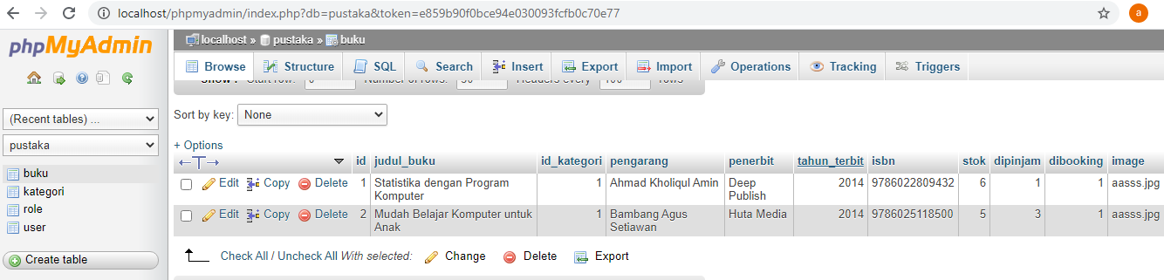 1. Table buku

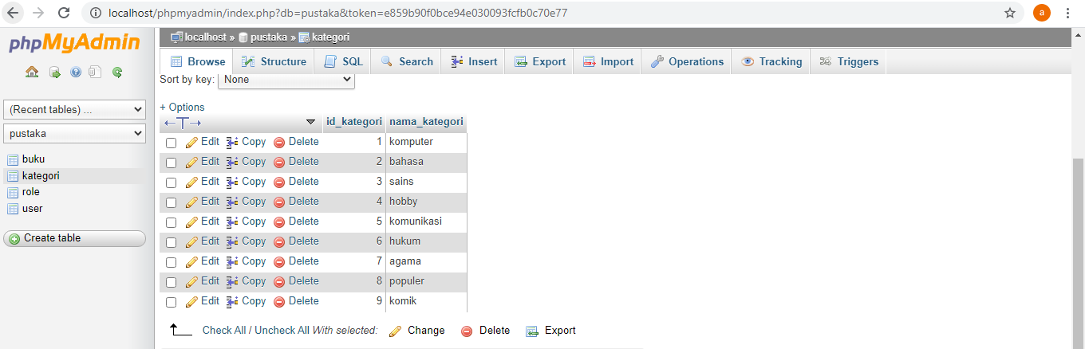2. Table kategori

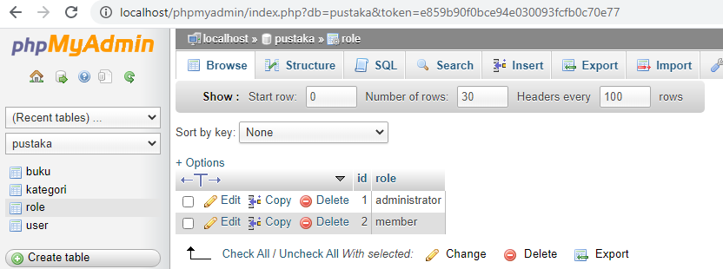3. Table role

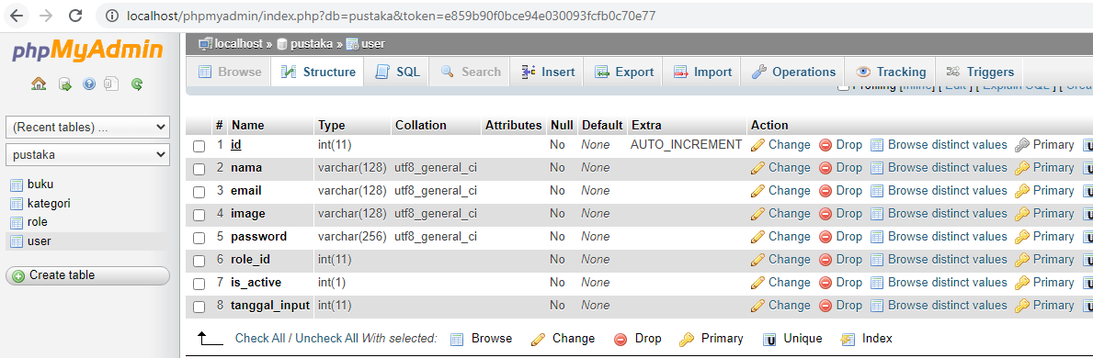4. Table user